Pi Mile Run Location and Race Route

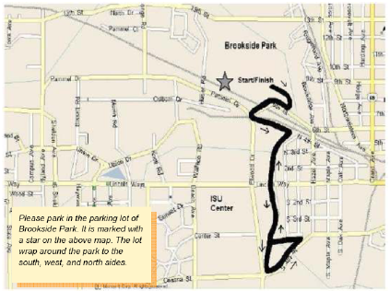

Directions:
To reach Brookside Park from outside of the Ames area, take I-35 exit 111 (HWY 30 West). Follow HWY 30 until the third exit (University Blvd). Take University Blvd. north past Lincoln Way and turn right at the stoplight at 6th St. Pass under the train bridge, and the entrance to Brookside Park is on the left. Please park and walk to the starting area.

